1.duplicate rows:
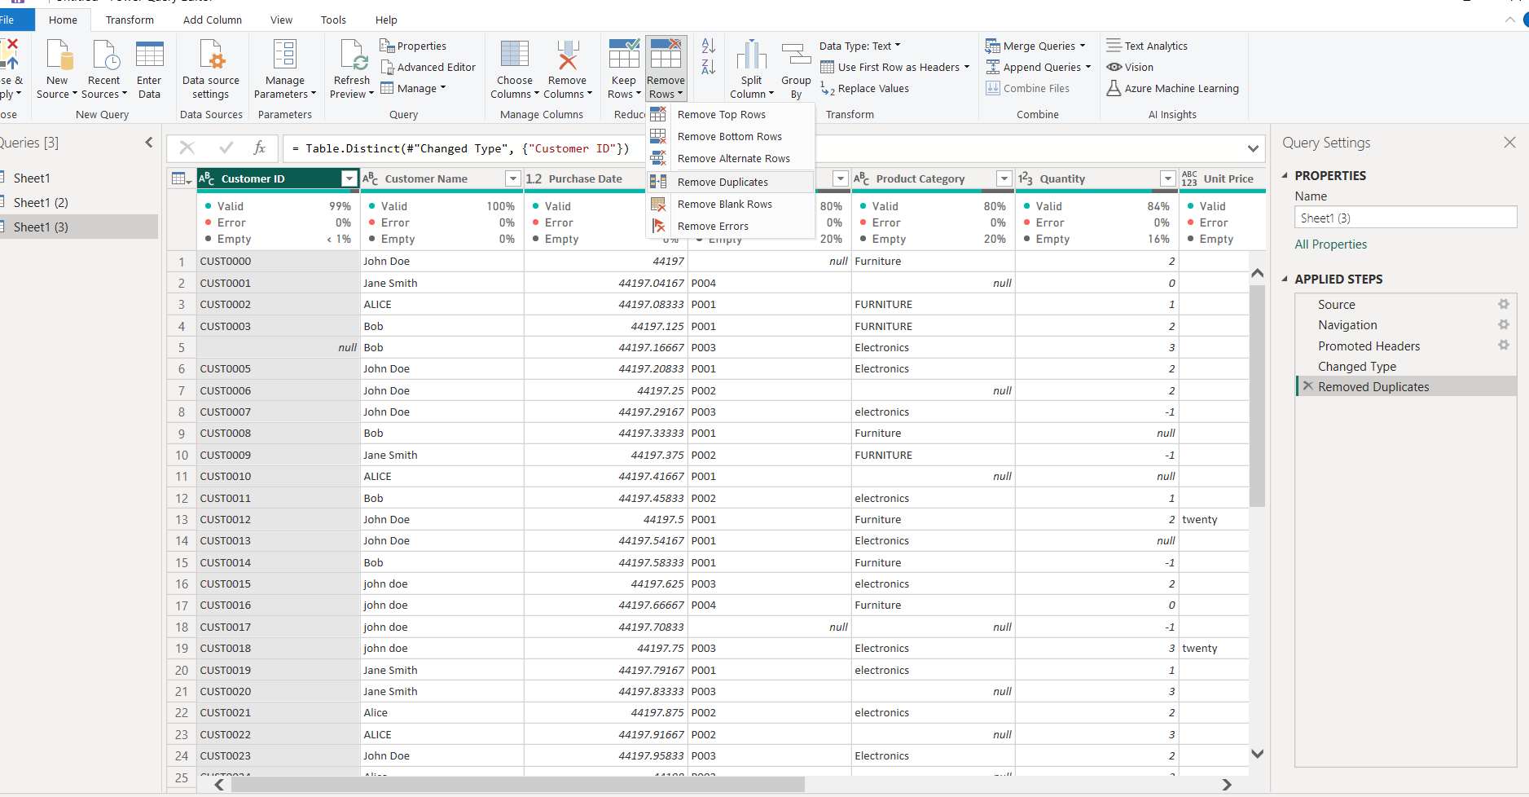
2. Standardize text fields:
- Convert 'Customer Name', 'Product Category', 'Payment Method', 'Region', and 'Returned' to consistent casing.
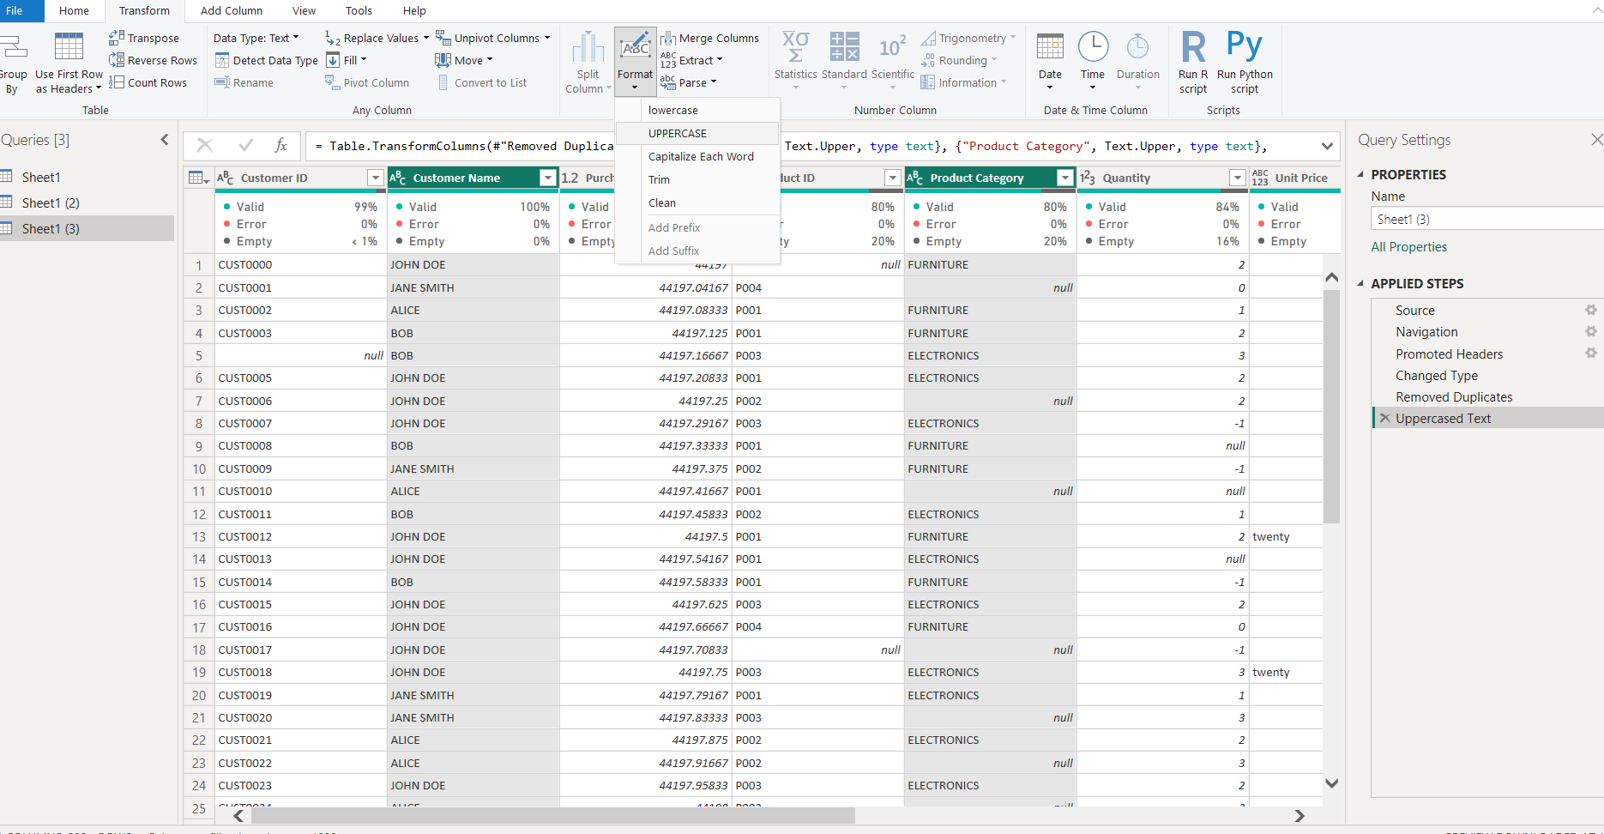

3. Handle missing values:
- Drop rows with missing 'Customer ID' or 'Product ID'.
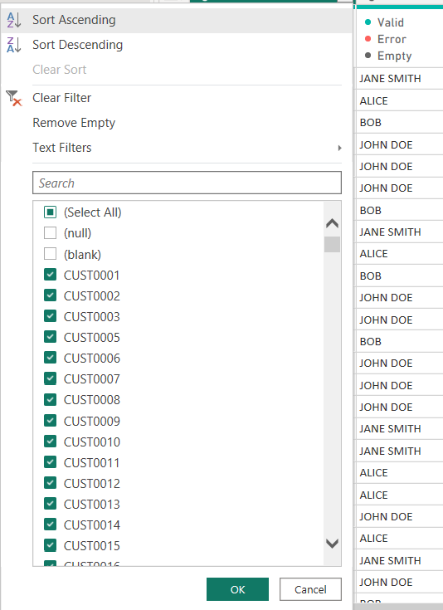

- Fill missing 'Quantity' with 1.
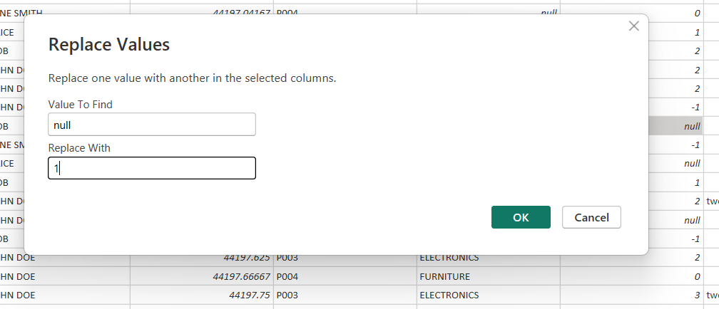
- Replace missing 'Unit Price' with the median of the column.
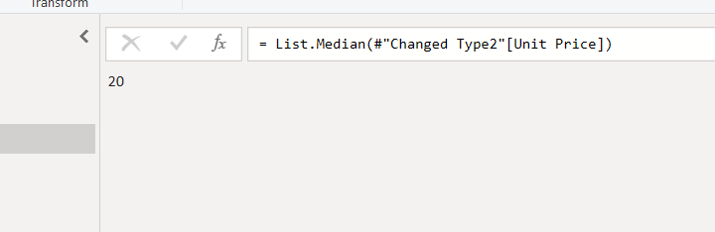
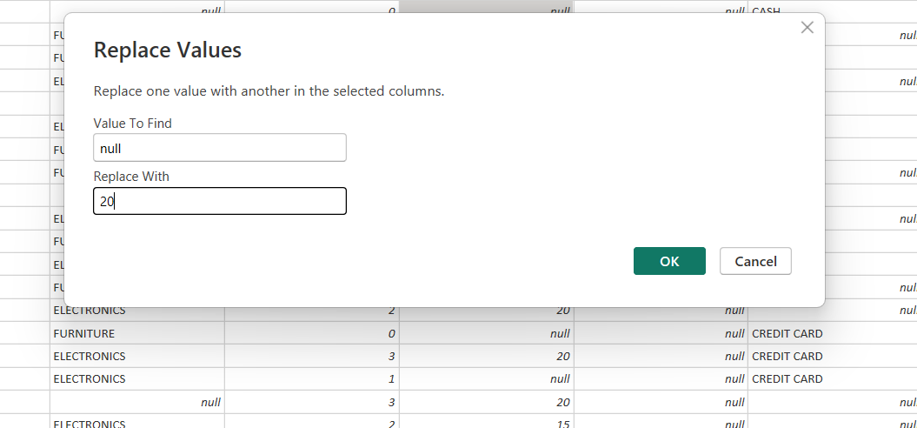

4. Fix data types:
- Convert 'Unit Price' to numeric (handle text like "twenty").
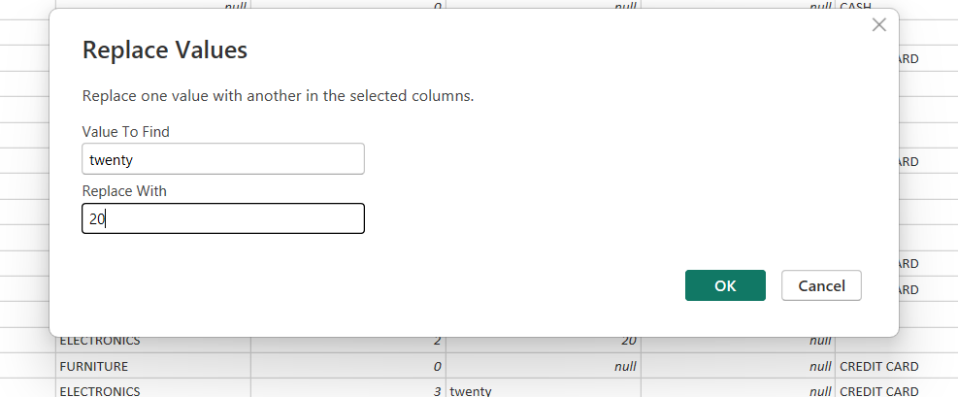
- Ensure 'Quantity' is a positive integer.
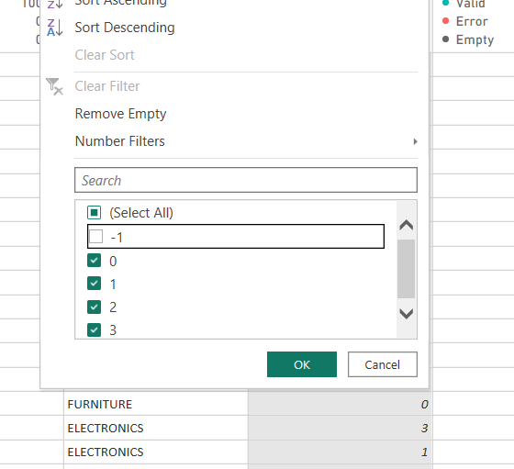
5. Calculate 'Total Price' = Quantity * Unit Price if missing.
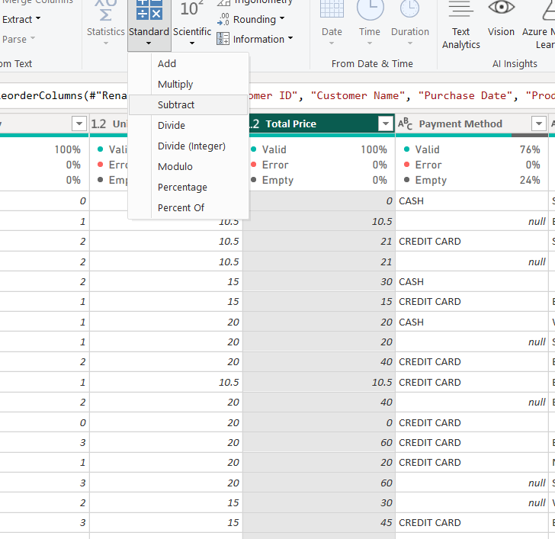

6. Remove rows with 'Quantity' <= 0.
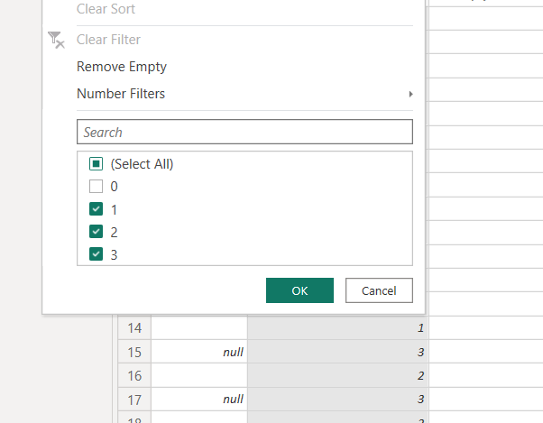

7. Trim leading/trailing spaces from text fields.
